1. Number Guessing Game
Problem: Write pseudocode for a number guessing game where the user has to guess a randomly generated number between 1 and 100. Provide hints ("Too High" or "Too Low") after each guess until the correct number is guessed.

2. Shopping Cart Total
Problem: Write pseudocode to calculate the total cost of items in a shopping cart. Use an array to store item prices, and a loop to sum the prices. Apply a discount if the total exceeds a certain amount.

3. Student Grades Calculator
Problem: Create pseudocode to calculate the average grade of a class. Prompt the user to enter grades for a specified number of students. Display the highest and lowest grades along with the average.

4. Multiplication Table Generator
Problem: Write pseudocode to generate a multiplication table for numbers from 1 to 10 using nested loops.

5. ATM Simulator
Problem: Write pseudocode for an ATM simulation that:
- Allows users to check their balance, withdraw money, or deposit money.
- Validates that the withdrawal amount doesn’t exceed the current balance.

6. Prime Number Checker
Problem: Write pseudocode to check if a number entered by the user is a prime number. Use a loop to test divisors and a conditional statement to determine primality.

7. Simple Calculator
Problem: Write pseudocode for a calculator that performs addition, subtraction, multiplication, or division based on user input.

8. Library Book Management
Problem: Write pseudocode for a library system that:
- Allows adding new books.
- Searches for a book by title.
- Displays all books in the library.

9. Hotel Room Booking System
Problem: Create pseudocode to manage hotel room bookings:
- Accept the number of rooms available.
- Allow the user to book rooms until all are reserved.
- Display a message when no rooms are left.

10. Weather Data Analysis
Problem: Write pseudocode to analyze weather data:
- Store daily temperatures for a week in an array.
- Calculate the average temperature.
- Determine the hottest and coldest days.

11. Tic-Tac-Toe Game
Problem: Write pseudocode for a two-player Tic-Tac-Toe game:
- Represent the board using a 2D array.
- Allow players to take turns until there is a winner or a draw.

12. Password Validation
Problem: Write pseudocode for a system that validates a password:
- Ensure the password is at least 8 characters long.
- Contains at least one uppercase letter, one lowercase letter, and one digit.
- Allow the user three attempts to enter a valid password.

Sample Answer

BEGIN PasswordValidation

MAX_ATTEMPTS ← 3

attempt_count ← 0

valid ← FALSE

WHILE attempt_count < MAX_ATTEMPTS AND valid = FALSE DO

PRINT "Enter your password: "

password ← INPUT()

IF LENGTH(password) >= 8 THEN

IF CONTAINS_UPPERCASE(password) AND

CONTAINS_LOWERCASE(password) AND

CONTAINS_DIGIT(password) THEN

valid ← TRUE

PRINT "Password is valid!"

ELSE

PRINT "Password must include at least one uppercase letter, one lowercase letter, and one digit."

END IF

ELSE

PRINT "Password must be at least 8 characters long."

END IF

attempt_count ← attempt_count + 1

END WHILE

IF NOT valid THEN

PRINT "Maximum attempts reached. Access denied."

END IF

END PasswordValidation

FUNCTION CONTAINS_UPPERCASE(password)

FOR EACH char IN password DO

IF char IS UPPERCASE THEN

RETURN TRUE

END IF

END FOR

RETURN FALSE

END FUNCTION

FUNCTION CONTAINS_LOWERCASE(password)

FOR EACH char IN password DO

IF char IS LOWERCASE THEN

RETURN TRUE

END IF

END FOR

RETURN FALSE

END FUNCTION

FUNCTION CONTAINS_DIGIT(password)

FOR EACH char IN password DO

IF char IS DIGIT THEN

RETURN TRUE

END IF

END FOR

RETURN FALSE

END FUNCTION

13. Payroll System
Problem: Write pseudocode to calculate employee salaries:
- Input the number of hours worked and hourly pay rate.
- Include overtime pay for hours worked beyond 40 hours (1.5 times the regular rate).
• Inputs:
- hours_worked: Total hours the employee worked.
- hourly_rate: Employee's pay per hour.
• Overtime Logic:
- Employees working more than 40 hours qualify for overtime.
- Overtime hours are calculated as hours_worked - 40.
- Overtime pay rate is 1.5 times the regular hourly rate.
• Salary Calculation:
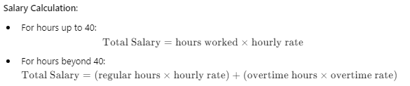•Output:
- Display the total salary.

14. Traffic Light System
Problem: Write pseudocode to simulate a traffic light system:
- Use a loop to switch between "Red," "Yellow," and "Green" states.
- Each state lasts for a specific number of seconds
Red 30s Green 25s Yellow 5s

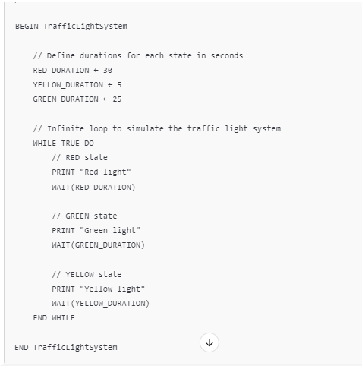

15. Palindrome Checker
Problem: Write pseudocode to check if a given string is a palindrome:
- Ignore spaces, punctuation, and case.
- Display whether the string is a palindrome or not.

16. Fibonacci Sequence Generator
Problem: Write pseudocode to generate the first n terms of the Fibonacci sequence. Use a loop and an array to store the terms.

17. Inventory Management System
Problem: Write pseudocode to manage a store's inventory:
- Allow adding, removing, and updating items.
- Display the current stock and total value of the inventory.

18. Banking Interest Calculator
Problem: Write pseudocode to calculate compound interest for a given principal, rate, and time period. Allow the user to choose between monthly, quarterly, or yearly compounding.
• Inputs:
- User provides:
  - Principal amount (P).
  - Annual interest rate (R).
  - Time period (T).
  - Compounding frequency (monthly, quarterly, or yearly).
• Frequency Handling:
- Depending on the user’s choice, the number of compounding periods per year (frequency) is set.
• Compound Interest Formula:
- Formula used:
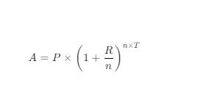
- Where:
  - A is the total amount after interest.
  - P is the principal.
  - R is the annual interest rate (decimal).
  - n is the compounding frequency per year.
  - T is the time period in years.
• Output:
- Display the total amount (A) and the compound interest (A - P).
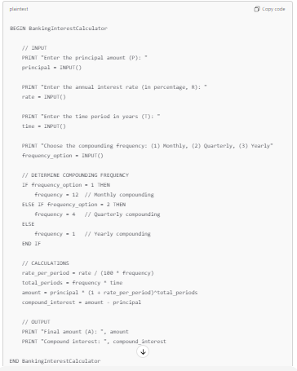

19. Maze Solver
Problem: Write pseudocode for a maze-solving algorithm using recursion:
- Mark visited paths to avoid loops.
- Find the shortest path from the start to the exit.

20. Voting System
Problem: Write pseudocode for a simple voting system:
- Input candidates and their votes.
- Calculate the winner based on the highest votes.
- Handle ties with a runoff process.

2
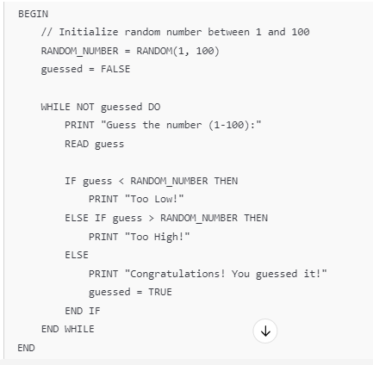

2. BEGIN
FOR row FROM 1 TO 5 DO
FOR column FROM 1 TO 5 DO
PRINT row * column, " "
END FOR
PRINT newline
END FOR
END

3. BEGIN
PRINT "Enter a number:"
READ num
isPrime = TRUE

IF num <= 1 THEN
isPrime = FALSE
ELSE
FOR i FROM 2 TO num / 2 DO
IF num MOD i == 0 THEN
isPrime = FALSE
BREAK
END IF
END FOR
END IF
IF isPrime THEN
PRINT "The number is prime."
ELSE
PRINT "The number is not prime."
END IF
END

4.
BEGIN
attempts = 0
isValid = FALSE

WHILE attempts < 3 AND NOT isValid DO
PRINT "Enter your password:"
READ password

IF LENGTH(password) >= 8 AND
CONTAINS_UPPERCASE(password) AND
CONTAINS_LOWERCASE(password) AND
CONTAINS_DIGIT(password) THEN
PRINT "Password is valid."
isValid = TRUE
ELSE
PRINT "Password is invalid. Try again."
attempts = attempts + 1
END IF
END WHILE

IF NOT isValid THEN
PRINT "Maximum attempts reached. Access denied."
END IF
END

5.
BEGIN
PRINT "Enter the number of students:"
READ n
grades = ARRAY[n]

FOR i FROM 1 TO n DO
PRINT "Enter grade for student", i, ":"
READ grades[i]
END FOR

total = 0
highest = grades[1]
lowest = grades[1]

FOR i FROM 1 TO n DO
total = total + grades[i]
IF grades[i] > highest THEN
highest = grades[i]
END IF
IF grades[i] < lowest THEN
lowest = grades[i]
END IF
END FOR

average = total / n
PRINT "Average grade:", average
PRINT "Highest grade:", highest
PRINT "Lowest grade:", lowest
END
6.
BEGIN
books = ARRAY[]
choice = 0

WHILE choice != 4 DO
PRINT "1. Add Book"
PRINT "2. Search Book"
PRINT "3. Display All Books"
PRINT "4. Exit"
READ choice

IF choice == 1 THEN
PRINT "Enter book title:"
READ title
APPEND books, title
PRINT "Book added."
ELSE IF choice == 2 THEN
PRINT "Enter book title to search:"
READ searchTitle
found = FALSE
FOR book IN books DO
IF book == searchTitle THEN
PRINT "Book found:", book
found = TRUE
BREAK
END IF
END FOR
IF NOT found THEN
PRINT "Book not found."
END IF
ELSE IF choice == 3 THEN
PRINT "Books in the library:"
FOR book IN books DO
PRINT book
END FOR
ELSE IF choice != 4 THEN
PRINT "Invalid choice. Try again."
END IF
END WHILE
END

FOR EACH character IN password DO
IF character IS UPPERCASE THEN
SET hasUpper = TRUE
ELSE IF character IS LOWERCASE THEN
SET hasLower = TRUE
ELSE IF character IS DIGIT THEN
SET hasDigit = TRUE
END IF
END FOR

// Step 5: Final validation
IF hasUpper = TRUE AND hasLower = TRUE AND hasDigit = TRUE THEN
SET isPasswordValid = TRUE
PRINT "Password is valid!"
ELSE
PRINT "Invalid password! Ensure it meets all the criteria."
END IF
ELSE
PRINT "Password must be at least 8 characters long."
END IF

// Step 6: Increment attempts
INCREMENT attempts
END WHILE

// Step 7: Check if attempts exhausted
IF isPasswordValid = FALSE THEN
PRINT "You have used all attempts. Access denied."
END IF

PRINT "Thank you for using the Password Validation System!"
END PasswordValidation

How It Works:
- Password Criteria:
  - At least 8 characters.
  - Contains at least one uppercase letter, one lowercase letter, and one digit.
- Attempts Limit:
  - The user has three attempts to enter a valid password.
- Validation Process:
  - The password is checked against the criteria using flags (hasUpper, hasLower, hasDigit).
  - If the password is valid, the process ends successfully.
  - If invalid, the user is informed and prompted again until attempts run out.
- End Conditions:
  - If the password is valid, a success message is displayed.
  - If all attempts are exhausted, the user is locked out.
Would you like this pseudocode converted into a specific programming language? 😊
4o

